Entering and Plotting Data Points (TI-83, 84)

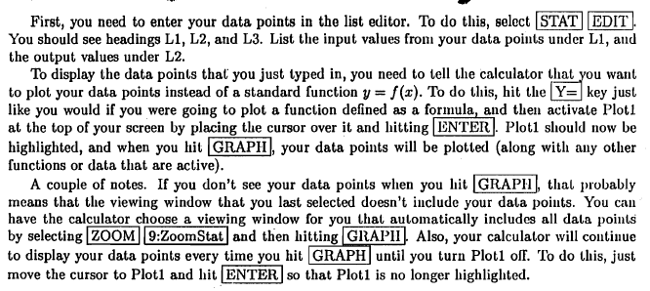

To find the line, quadratic, cubic, quartic, exponential, power function of best fit you will need to

 ‘Then find the desire function’ then 

Example if Line of best fit



If you use this then the function will be placed into Y1 of your calculator. Or you can type the function in yourself if you like.

Quadratic of best fit

