Quilt-It!  A Girl Scout Brownie  Try-It Badge  After being developed and tested in 2006, a new Brownie Try-It Badge is available. Each Brownie quilts a four patch pot holder, doing her own work on every step. All piecing and quilting is done by hand, with typical completion times of five to seven hours. |  |  | 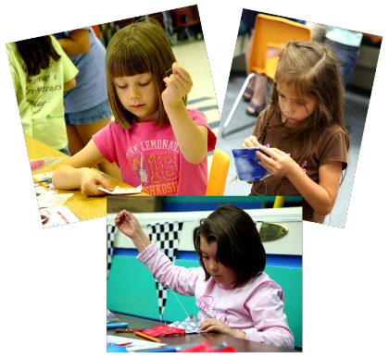
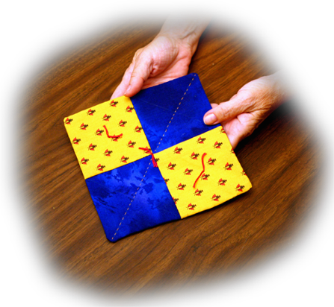  Visit the Photo Gallery | Objectives  ♦ Have fun quilting  ♦ Follow directions  ♦ Keep on task  ♦ Complete a quilt  ♦ Trace a pattern  ♦ Cut with scissors  ♦ Sew running stitches  ♦ Appreciate basic  quilting history  ♦ Understand and use  quilting terms
Find out more
Badge Requirements
What You Will Need
Illustrated Directions
Word File
PDF file
Leader Support
Quilt Terms
Try-It Badge Order Form

Back to Quilt-It! home page
If there is no side bar menu, click on start Quilt-It!
Created by Sharon L. Thompson and Richard B. Thompson  Tucson Quilters Guild  For the Sahuaro Girl Scout Council |  | Download printer friendly version of page:  Word pdf

