Quilt-It!  A Girl Scout  Cadette and Senior  Interest Project  After being developed and tested in 2007, a new nationally recognized Cadette/Senior Interest Patch is available. Each scout designs and makes a quilt of her choice. By completing the requirements in the Learn, Do, Share, and Reflection sections, she will have a well rounded experience with the art of quilting. | 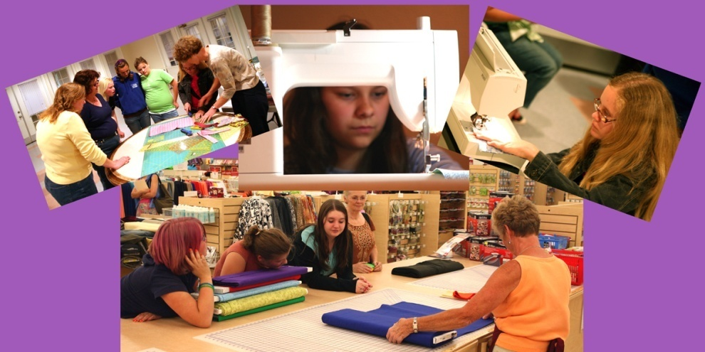
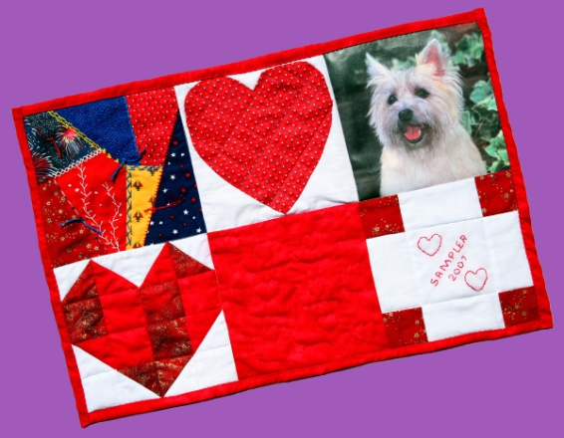  Visit the Photo Gallery | Objectives  ♦ Enjoy quilting  ♦ Work independently  ♦ Follow written directions  ♦ Complete a quilt  ♦ Sew by hand or with a machine  ♦ Share new skills with others  ♦ Be familiar with  quilting history  ♦ Understand and use  quilting terms
Find out more
IP Requirements
Leader Support
Quilting Terms
Badge Order Form

Back to Quilt-It! home page
If there is no side bar menu, click on start Quilt-It!
Created by Sharon L. Thompson and Richard B. Thompson  Tucson Quilters Guild  For the Sahuaro Girl Scout Council |  | Download printer friendly version of page:  Word pdf

