Girl Scout Badge Requirements:  QUILT-IT!  A Cadette/Senior Interest Project |  |  | 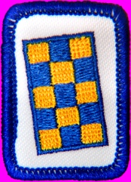
GIRL SCOUT IP RULES
In order to earn a badge in any Interest Project you must complete the following.
* Do the one Required Activity.
* Do one activity of your choice from each of the three
categories: Learn, Do, and Share.
* Design and carry out one activity of your own.
* Create a short Reflection after you've completed all of the
other activities.
QUILTS
The earliest known quilt was made in Egypt around 980 B.C. According to a dictionary definition, "A quilt is a coverlet for a bed, made of two layers of fabric with some soft substance between them and stitched in patterns through all thicknesses to prevent the filling from shifting." Quilts are much more than that! Looking through history, one can find quilted clothing as well as bedding. Today, quilts range from traditional bed coverlets, to wearable art, to wall hangings.
Quilt tops are often created by sewing together quilt blocks. These are usually square design components that have been made with fabric, using a particular quilting technique.
Quilt-It  REQUIRED Activity  Make a quilt! This may be done by hand stitching, with a sewing machine, or by a combination of both methods. Your quilt should include blocks that are created with piecing, applique, or redwork.  Pieced blocks are made by sewing pieces of fabric together. Appliqued blocks are made by cutting shapes and sewing them on top of a fabric foundation. Often these two techniques are combined in one quilt. Redwork is a technique in which the design is outlined with embroidery in a single color, traditionally red or blue. |  |  |  |  | 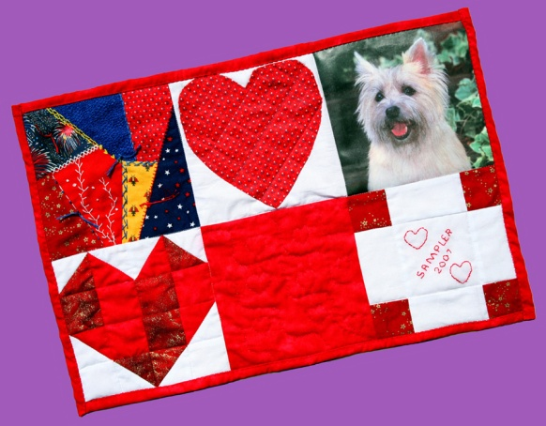
Your quilt should be at least 11 inches by 18 inches with hand or machine quilting. You may embellish your quilt with buttons, bows, beads, charms, pictures, or whatever else suits your fancy. This is your quilt!

LEARN
1. Invite a quilter to advise you, or your group, on various quilt techniques.
2. Visit a professional quilter to learn what career opportunities exist in this field.
3. Explore the history of quilting and give a report to your troop on what you have learned.
4. Visit a quilt shop and learn about different fabrics and quilting accessories.

DO
1. Make and keep a quilt journal. Include ideas, thoughts, and dates for the beginning and completion of your projects.
2. Carry out the complete design process for an original quilt that is different from your required project. The quilt top may be planned with paper and pencil, common computer software, or specialized software. Determine the yardage needed for each segment of the work, colors of fabric desired, and finished size. Magazines and books devoted to quilting are available from libraries, new and used bookstores, and the Internet. These can provide valuable design ideas. Write a paragraph explaining the motivation for your design. The emphasis of this activity is the design process. You may wish to make the quilt, but this is not a requirement.
3. Make sample blocks illustrating piecing, applique, redwork, and crazy quilting.
4. Hang your quilt in a quilt show.
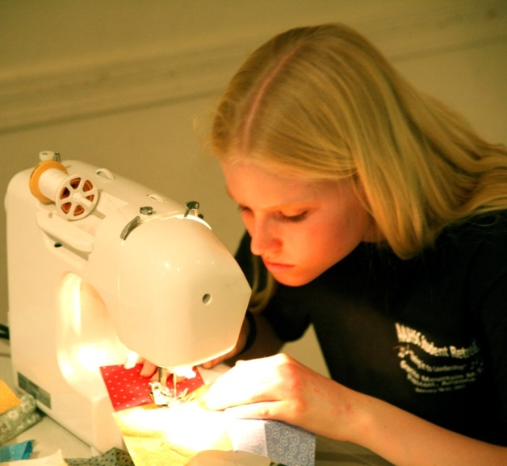 |  |  | SHARE  1. Help younger girls learn to quilt. A pot holder is an ideal beginning project. See the Brownie Quilt-It Try-It for full instructions.  2. Make and send "quilted" postcards to pen pals.  3. Make placemats for Meals on Wheels or Mobile Meals.  4. Get together with others and make a group quilt to donate to a worthy cause, or for a raffle to support a worthy cause.  YOUR OWN ACTIVITY  1. Plan a block swap with your quilting friends. Create a common block design, which each girl makes with her own choice of fabrics. Each member of the group should make enough identical blocks with her fabrics, and the common
design to swap with the other quilters. Exchange blocks within the group so that each person has a complete set of different blocks. These can then be used to complete quilts.
2. Create a block design challenge. This is a contest in which each person is challenged to create a quilt block, subject to fixed specifications for size of the block, number of different fabrics to be used, particular technique to be used, or a particular piece of fabric that should be included. Make up your own rules for the challenge blocks.
3. Design your own quilting activity.

REFLECTION
1. Write about your experiences with this project.
2. Create a computer presentation on your quilting project, using PowerPoint or some other presentation software.
3. Create a graphic display about your project, using a story board and other materials.
Back to Cadette/Senior page |  |  | Back to Quilt-It! home page
If there is no side bar menu, click on start Quilt-It!
Created by Sharon L. Thompson and Richard B. Thompson  Tucson Quilters Guild  For the Sahuaro Girl Scout Council |  |  |  | Download printer friendly version of page:  Word pdf

