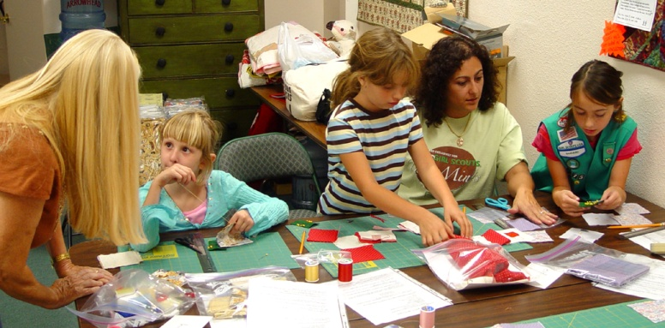 |  |  |  |  | QUILTING BADGE WORK  Developed by  Sharon L. Thompson  Tucson Quilters Guild
Your troop can earn  Girl Scout USA approved quilting badges! |  |  |  |  |  | Quilt-It! projects provide fun and creative ways for Brownies, Juniors, and Cadette/Seniors to learn basic quilting skills. The Try-It, Badge, and Interest Project were developed by members of the Tucson Quilters Guild Education Committee.
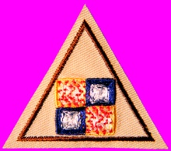 | 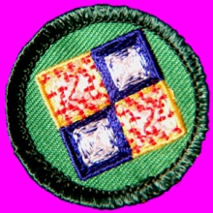 |  |  | 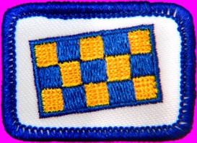
Quilt-It! projects have been successfully used by Brownie, Junior, and Cadette/Senior troops in the Sahuaro Girl Scout Council. The Council has also processed badge orders for over 350 girls from 20 states! Attractive quilts were produced, with both the scouts and their leaders enjoying the work. Brownies make basic four-patch pot holders, Juniors create simple placemats, Cadette/Seniors create more elaborate quilts of their own design. Elementary skills are taught, so that all work can be completed by hand sewing and quilting. Sewing machines are an option for more advanced girls.
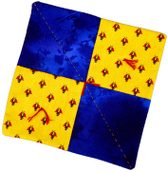 |  | This web site provides all of the information, directions, and leader support that are needed for a troop to undertake and successfully complete a Quilt-It! project. The projects can be carried out during consecutive troop meetings, or in a longer workshop setting. They are also ideally suited for day camp programs. |  |  |  |  | View streaming video of the Quilt-It! project.
 |  |  |  |  |  |  |  | 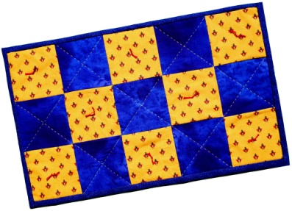
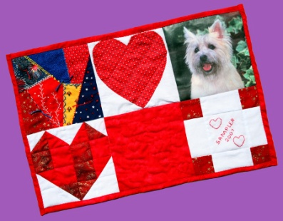 |  |  | For more information contact Sharon L. Thompson  through the Sahuaro Girl Scout Council.  Sahuaro Girl Scout Council: http://sahuarogsc.org  Tucson Quilters Guild: http://tucsonquiltersguild.com  If there is no side bar menu, click on start Quilt-It!
Created by Sharon L. Thompson and Richard B. Thompson  Tucson Quilters Guild  For the Sahuaro Girl Scout Council  Web site maintained by Richard B. Thompson  Last modified: January 5, 2009 |  |  |  |  |  |  |  | Download printer friendly version of page:  Word pdf

