Girl Scout Badge Requirements:  QUILT-IT!  A Junior Badge |  |  | 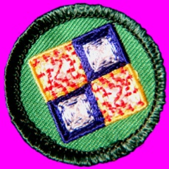
Complete 6 of the following activities:  * required activity  *1. Piece a placemat quilt top.  *2. Assemble the quilt sandwich and quilt your placemat.  *3. Complete your placemat by binding the edges.  4. Visit a quilt show or quilt exhibit.  5. Visit a quilt shop.  6. Show your quilt project at your school, a Girl Scout Office, or a quilt show.  7. Learn the names and draw pictures of 4 different traditional quilt patterns.  8. Prepare a report on at least two groups of people who quilt, describing what makes their quilts unique.  9. Keep a diary of your quilting project.  10. Design your own quilt, drawing it to scale on graph paper or with a computer.  11. Design and create your own quilt block.  12. Read a book about quilting or quilters and prepare a report for your troop.  13. Make a quilt or help your troop make a quilt that will be donated to others. |  |  |  |  | 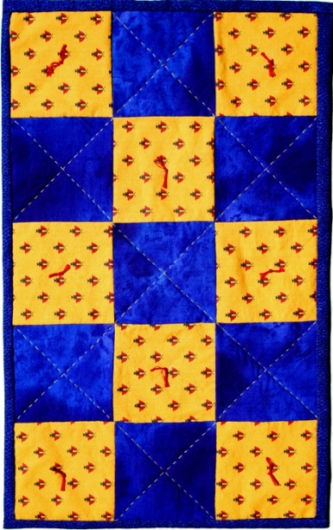
Back to Junior page |  | Back to Quilt-It! home page
If there is no side bar menu, click on start Quilt-It!
Created by Sharon L. Thompson and Richard B. Thompson  Tucson Quilters Guild  For the Sahuaro Girl Scout Council |  |  |  | Download printer friendly version of page:  Word pdf

