MAKING MY QUILTED PLACEMAT
Created by Sharon L. Thompson and Richard B. Thompson
Tucson Quilters Guild, 2006
You will need:
A 24 inch by 24 inch piece of fabric Pencil or chalk marker
A 12 inch by 24 inch piece of a different fabric Scissors
An 12-1/2 inch by 20-1/2 inch piece of batting 4-1/2 inch square template
Thread Skein of embroidery floss
Needles Ruler
Straight pins

Step 1: Following the fabric layout below, trace around the 4-1/2 inch by 4-1/2 inch template on the wrong sides of both pieces of fabric to create 15 quilt blocks. Use your ruler to measure and draw a 14-1/2 inch by 22-1/2 inch quilt backing. Cut out the blocks and backing very carefully. Save the extra pieces of fabric. This is the start of your stash.

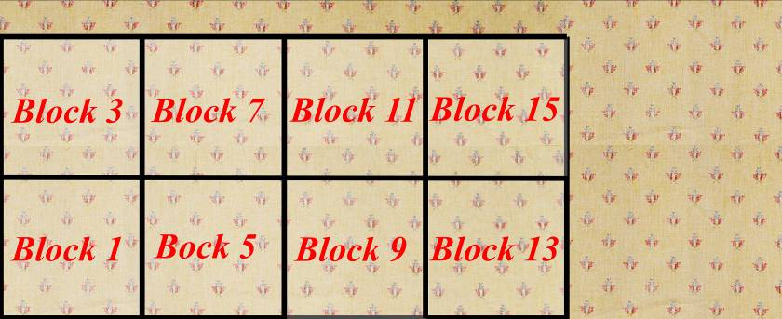

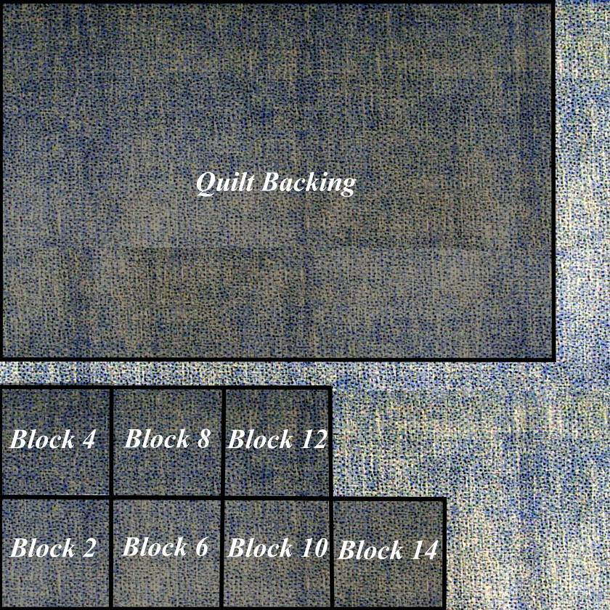

Step 2: Arrange the blocks in 3 rows of 5 blocks each, as shown below.
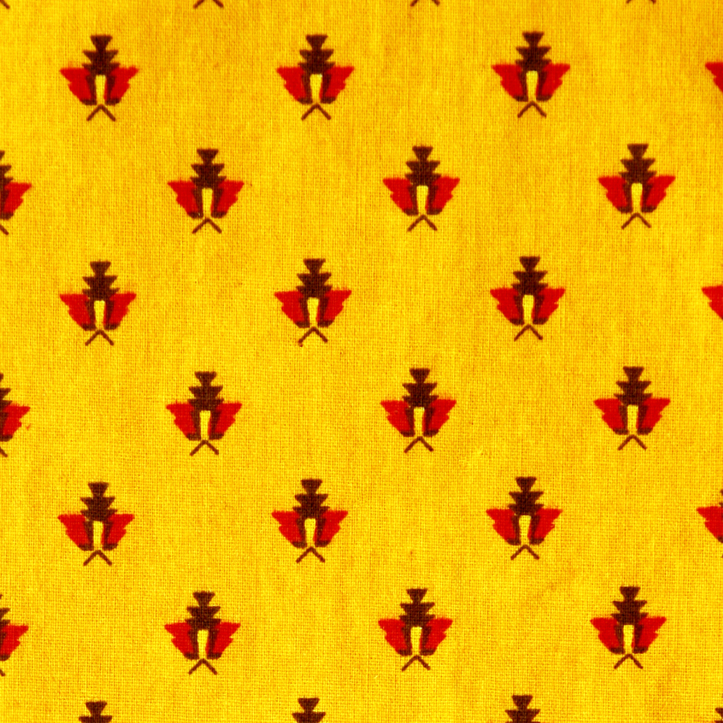
Block 1
Block 2
Block 8
Block 7
Block 5
Block 4
Block 3
Block 6
Block 10
Block 9
Block 15
Block 14
Block 13
Block 12
Block 11

Step 3: Start piecing the quilt top. Place Blocks 1 and 2 together, right side to right side. On the wrong side of the lighter colored block, draw a seam line 1/4 inch from the raw edge. Sew the two blocks together with a running stitch. Each stitch should be approximately 1/8 inch long. At this size, you will see 16 stitches on one side of the seam line. See the example below. Use your thumb to finger press the seam allowances toward the darker fabric. The two sewn blocks will be called Piece 1*2.

Step 4: Repeat Step 3 with Blocks 3 and 4 to form Piece 3*4. Sew Pieces 1*2 , 3*4, and Block 5 together to form the top row of your quilt top.

Step 5: Repeat Steps 3 and 4 to create the middle and bottom rows. Sew the three rows together and finger press all of the new seam allowances in one direction. You have now completed an 12-1/2 inch by 20-1/2 inch quilt top.
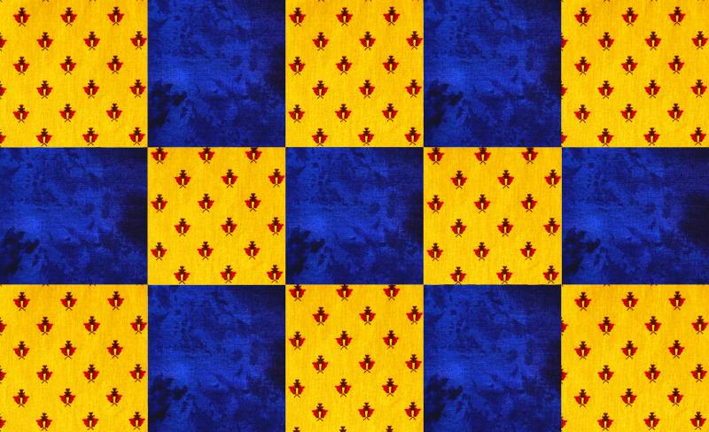

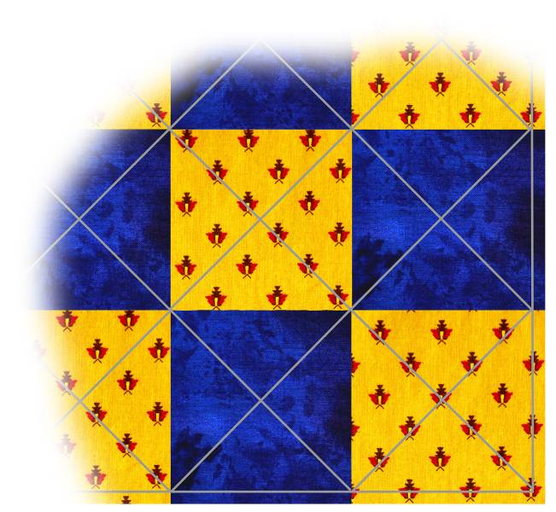
Step 6: Draw a seam line completely around the outside of your quilt top, 1/4 inch in from the outer edges. Draw diagonal lines from corners to corners in each quilt block. In the inner blocks (Blocks 7, 8, and 9) use the actual corners of the blocks. In the outside blocks use your seam lines to determine the corners.

Step 7: Cut an 12-1/2 inch by 20-1/2 inch piece of batting. Turn the quilt backing wrong side up and center the batting on the quilt backing. Place the quilt top right side up on top of the batting. The quilt backing will stick out 1 inch on all sides of the batting and quilt top. Baste the quilt top, batting, and quilt backing together with a long running stitch. This is the "quilt sandwich".
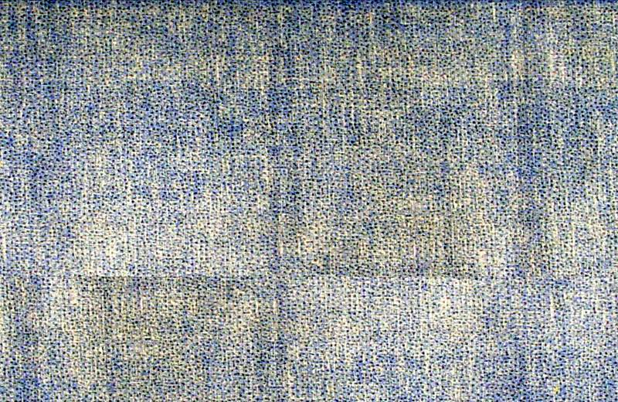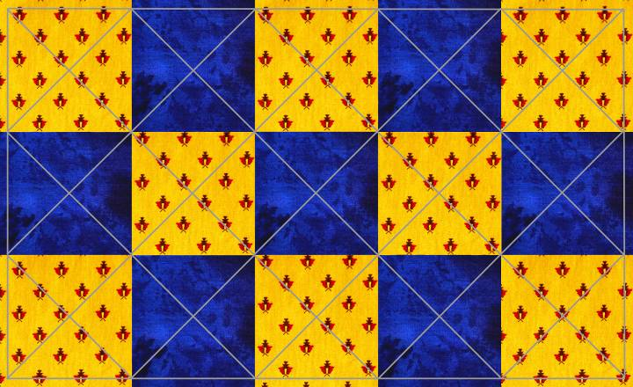

Step 8: Stitch along the lines in the middle block (Block 8) with a running stitch. Start down through the quilt top and pull the knot at the end of your thread through the fabric in the quilt top into the middle of the quilt sandwich. This hides the knot out of sight. Repeat the quilting in all of the other even numbered blocks (Blocks 2, 4, 6, 10, 12, and 14).
Step 9: Block 7 will be quilted by tying at the place where the two lines from Step 6 cross each other. Using embroidery floss and a large needle, sew a stitch with one inch long "tails" of floss through the quilt sandwich. The "tails" will be on the top of the pieced quilt top. Tie these with a square knot. The stitching described in Step 8 and the tying are both called hand quilting. When the quilting is finished, remove the basting threads. Rinsing with cold water will remove the lines that you drew.

Step 10: Starting with one of the long sides, fold the edge of the quilt backing over to the edge of the batting and quilt top. Finger press this down. Fold this edge over the quilt top up to the seam line, finger press this, and then pin it securely. Hem stitch the edge of the fold to the quill top. See the diagram below. Repeat this on the opposite side of the quilt. Repeat the folding and stitching process with both of the short sides. This process is called self binding.
Quilt Backing
Quilt Top
Batting
Stitching
1/4 ″

You have just made a quilt!
