Quilt-It!  Girl Scout Junior Badge |  |  | 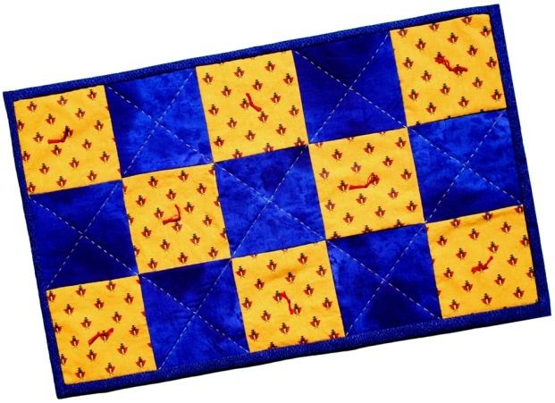
Each Junior will need the following supplies and tools for work on her placemat. It is usually convenient to provide this to each girl as a kit. Obviously, equipment, such as scissors and rulers, may be shared. While they are working on their quilts, all girls will also need access to the complete directions for the project. These may be downloaded as a Microsoft Word file or as a pdf file. Sets of directions may be provided for each girl, or several copies may be available in the work area.
You will need:
* Fabric: 2 pieces of different fabrics, one at least 9 x 22 inches and the other at least 18 x 22 inches.
* Batting: 1 precut 11 x 18 inch piece.
* Thread: 1 spool of all purpose thread.
* Pins: 15 straight pins with large bead heads.
* Needles: 2 sewing needles.
* Scissors: all purpose.
* Template: 4 x 4 inches cut from poster board or from gridded plastic sheet.
* Pencil: soft lead.
* Ruler: at least 12 inches.
* Embroidery Floss and Large Eyed Needle: for quilt tying.
A modification is possible that would simplify the project for those with time constraints or less experienced troops. Pre cut fifteen 4 x 4 inch squares of two different fabrics and one 13 x 20 inch square of fabric. It is also possible to pre-draw all seam lines and quilting lines. If this is done, templates, pencils, and rulers would not be necessary.
Back to Junior page |  | Back to Quilt-It! home page
If there is no side bar menu, click on start Quilt-It!
Created by Sharon L. Thompson and Richard B. Thompson  Tucson Quilters Guild  For the Sahuaro Girl Scout Council |  |  |  | Download printer friendly version of page:  Word pdf

