Quilt-It!  A Girl Scout  Junior Badge  After being developed and tested in 2006, a new Junior Badge is available. Each Junior quilts a fifteen patch placemat, doing her own work on every step. All piecing and quilting is done by hand, with typical completion times of ten to fifteen hours. |  | 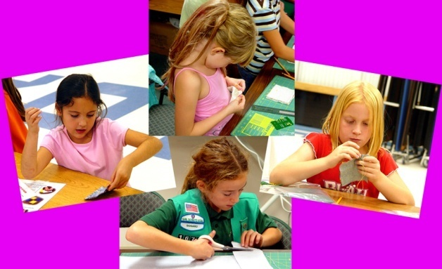
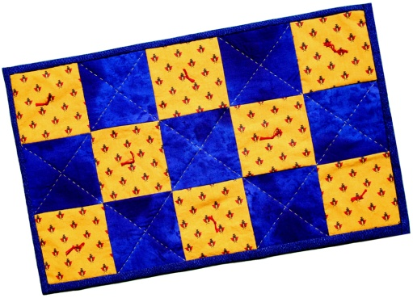  Visit the Photo Gallery | Objectives  ♦ Enjoy quilting  ♦ Work independently  ♦ Follow written directions  ♦ Complete a quilt  ♦ Lay out and cut quilt  blocks  ♦ Sew running and  hem stitches  ♦ Be familiar with  quilting history  ♦ Understand and use  quilting terms
Find out more
Badge Requirements
What You Will Need
Illustrated Directions
Word File
PDF file
Leader Support
Quilting Terms
Badge Order Form

Back to Quilt-It! home page
If there is no side bar menu, click on start Quilt-It!
Created by Sharon L. Thompson and Richard B. Thompson  Tucson Quilters Guild  For the Sahuaro Girl Scout Council |  |  | Download printer friendly version of page:  Word pdf

