Back to Brownie page | Back to Junior page |  | Back to Cadette/Senior page |  |  |  | Back to Quilt-It! home page
If there is no side bar menu, click on start Quilt-It!
QUILT-IT!  Girl Scout Quilting Badge Work  Developed by the Tucson Quilters Guild  Sharon L. Thompson  Leader Support  and  Resources |  |  |  |  | 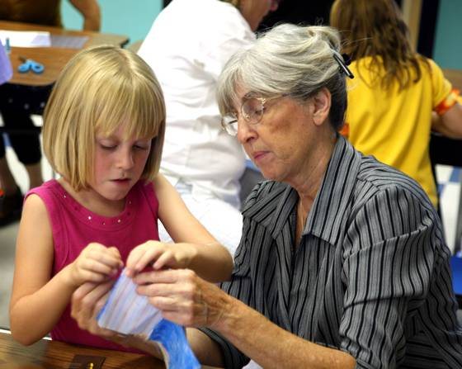
Quilting has existed since Egyptian times. Once a utilitarian skill, modern quilting now combines utility with art. The Quilt-It! projects are simple, but effective ways for girls to learn basic quilting skills.
Quit-It! can be enjoyed by a wide variety of troops. However, extra individual attention may be required by beginning Brownies or Juniors, or by those with low motivation. All troops will find it very useful to have leaders and helpers available for individual assistance.
It is important that the girls and those who are working with them follow the same steps and use the same terminology. This is best accomplished by downloading the complete, illustrated project directions and having printed copies distributed around the work area. Links to the directions, in either Microsoft Word documents or pdf files, can be found on the individual project pages for each level.
Cadette/Seniors should be encouraged to find quilting magazines and books at bookstores, quilt shops, and libraries. The Internet has several quilting sites that offer free instruction.

Finding Help and Supplies
There are several resources that can be used to locate donations of quilting supplies, information about quilting, and volunteers with quilting expertise.
♦ The Sahuaro Girl Scout Council. Visit their web site. http://www.sahuarogsc.org
♦ Quilt shops in your area. Leaders of troops in southern Arizona can contact any of the following shops. Tucson: Bella Quiltworks, Cactus Quilt Shop, Catalina Quilting, The Quilt Basket, Quilter's Market. Green Valley: Hearts and Hands. Sahuarita: Quilters Desert Patch. Sierra Vista: The Squirrel's Nest, Thimbleweed Quilts.
♦ Quilter's guilds and other organized groups of quilters. These can be located by inquiring at local quilt shops or by visiting http://www.quiltguilds.com. Leaders of troops in the Tucson, Arizona area can contact the Tucson Quilters Guild at http://tucsonquiltersguild.com.
♦ The internet. http://www.womenfolk.com/historyofquilts
http://www.mycoupons.com/store/a-guide-for-quilting-fanatics-resources-and-more
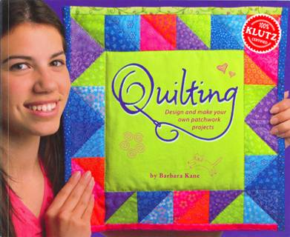 |  | The following books may be of interest. Others might be found at your local library.  ♦ The Klutz Book, Quilting, by Barbara Kane, ISBN 1-57054-215-5. This book has excellent illustrations and additional quilting projects.  ♦ The Quilt-Block History of Pioneer Days, by Mary Cobb, ISBN 1-56294-692-7. |  |  |  |  |  |  | 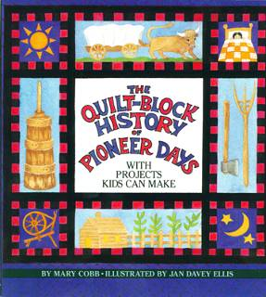
Project Modifications  Time constraints or the experience level of the girls may require some adjustments in the projects. This is completely appropriate, as long as the basic Try-It, Badge, or Interest Project requirements are still satisfied.  Brownies. One possible modification of the Brownie Try-It would be for the leader or helpers to precut the fabric pieces and then draw the seam and quilting lines. This would involve drawing seam lines 1/4 inch in from the edges on the wrong sides of all four quit top blocks and the quilt backing. Diagonal lines would also be drawn on the right sides of the quilt top blocks. Some of these will serve a quilting lines and others will be used to locate the center of the blocks for quilt tying. |  |  |  |  |  | 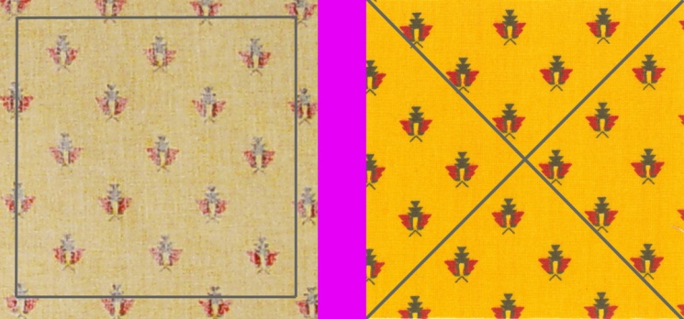
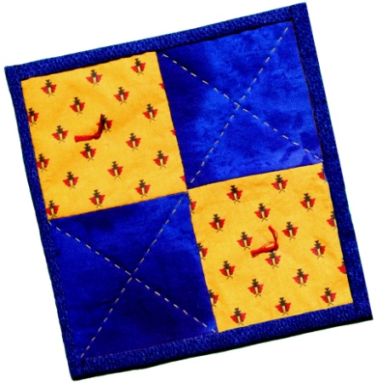 |  |  |  |  |  | Juniors. Girl Scouts at the Junior level could scale back the placemat project to produce a sophisticated version of the four patch potholder. This would be made from the standard placemat directions, using the quilting and binding techniques from the full Junior project. A considerably reduction in the duration of the project would result, since four, rather than fifteen, squares would be used.  Juniors with some prior sewing experience, might be able to use a sewing machine to machine piece a placemat quilt top.
Going Beyond Badge Work
Day Camp. The Quilt-It! potholder project provides an excellent activity for a Girl Scout Day Camp. The modification suggested above would provide kits that allowed Brownies to handle the work in a reasonable period of time. Older girls might start from the kits or, if enough time is available, they could complete the full potholder project.
Mommy And Me. Experience with the quilting projects shows that Quilt-It! is an excellent program for Mommy And Me activities. In this context, some prior training and practice for the mothers would be quite important.
Service. Girl Scouts at the Junior and more advanced levels can find many opportunities for the use of quilting in service projects. There is a great need for such items as lap quilts in assisted living facilities, and baby quilts that are given to needy families. The production and presentation of such quilts provides an excellent activity for troop service.
Back to Brownie page | Back to Junior page |  |  | Back to Cadette/Senior page |  |  |  | Back to Quilt-It! home page
If there is no side bar menu, click on start Quilt-It!
Created by Sharon L. Thompson and Richard B. Thompson  Tucson Quilters Guild  For the Sahuaro Girl Scout Council |  |  |  |  |  |  | Download printer friendly version of page:  Word pdf

