Quilt-It!  Girl Scout Brownie Try-It Badge |  |  |  | 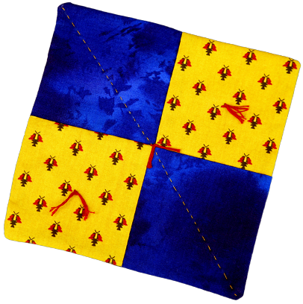
Each Brownie will need the following supplies and tools for work on her pot holder. It is usually convenient to provide this to each girl as a kit. Obviously, equipment, such as scissors and rulers, may be shared. While they are working on their quilts, all girls will also need access to the complete directions for the project. These may be downloaded as a Microsoft Word file or as a pdf file. Sets of directions may be provided for each girl, or several copies may be available in the work area.
You will need:
* Fabric: 2 pieces of different fabrics, each at least 9 x 22 inches.
* Batting: 1 precut 8 x 8 inch piece.
* Thread: 1 spool of all purpose thread.
* Pins: 5 straight pins with large bead heads.
* Needles: 2 sewing needles.
* Scissors: all purpose.
* Small Template: 4-1/2 x 4-1/2 inches cut from poster board or from gridded plastic sheet.
* Large Template: 8-1/2 x 8-1/2 inches cut from poster board or from gridded plastic sheet.
* Pencil: soft lead.
* Ruler: or other straight edge.
* Embroidery Floss and Large Eyed Needle: for quilt tying.
A modification is possible that would simplify the project for those with time constraints or less experienced troops. Pre cut four 4-1/2 x 4-1/2 inch squares of two different fabrics and one 8-1/2 x 8-1/2 inch square of fabric. It is also possible to pre-draw all seam lines and quilting lines. See the section on Leader Support for details. If this is done, templates, pencils, and rulers would not be necessary.
Back to Brownie page |  | Back to Quilt-It! home page
If there is no side bar menu, click on start Quilt-It!
Created by Sharon L. Thompson and Richard B. Thompson  Tucson Quilters Guild  For the Sahuaro Girl Scout Council |  |  | Download printer friendly version of page:  Word pdf

